**MongoDB Day-1**

**Q1. Find all the information about each products.**

**QUERY: db.products.find();**

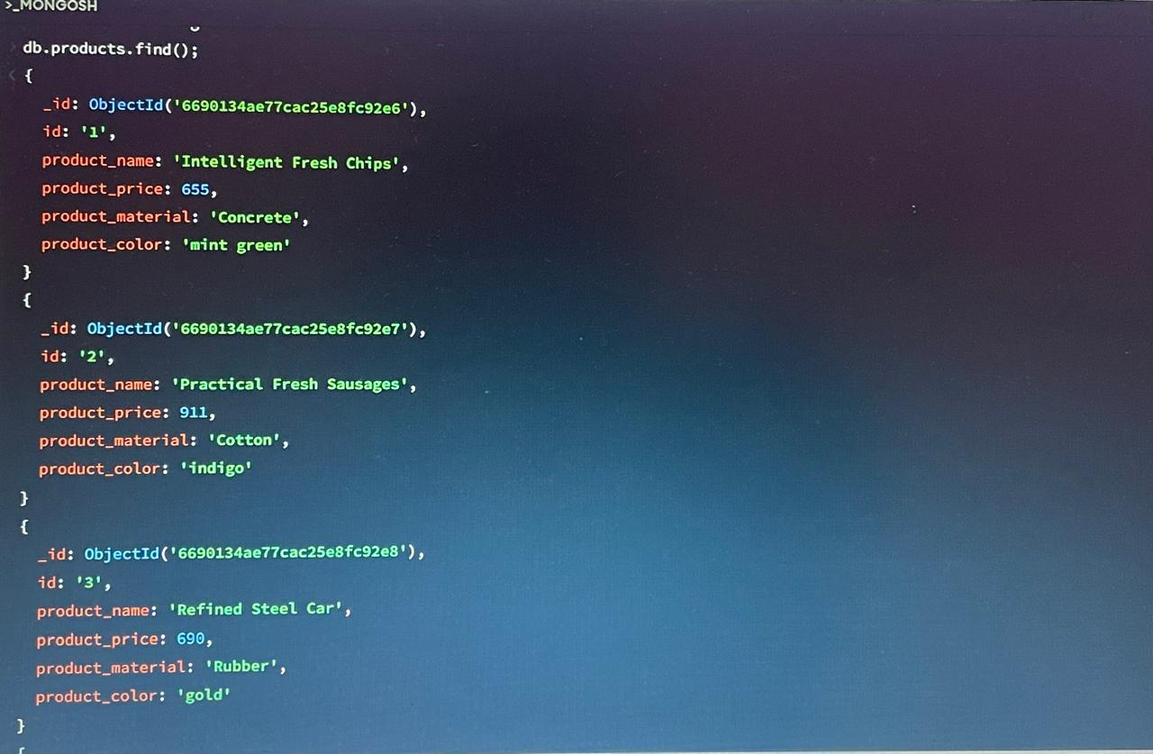

# Q2. Find the product price which are between 400 to 800

# QUERY:

# db.products.find({

# product_price:{$gte:400, $lte:800

# }});

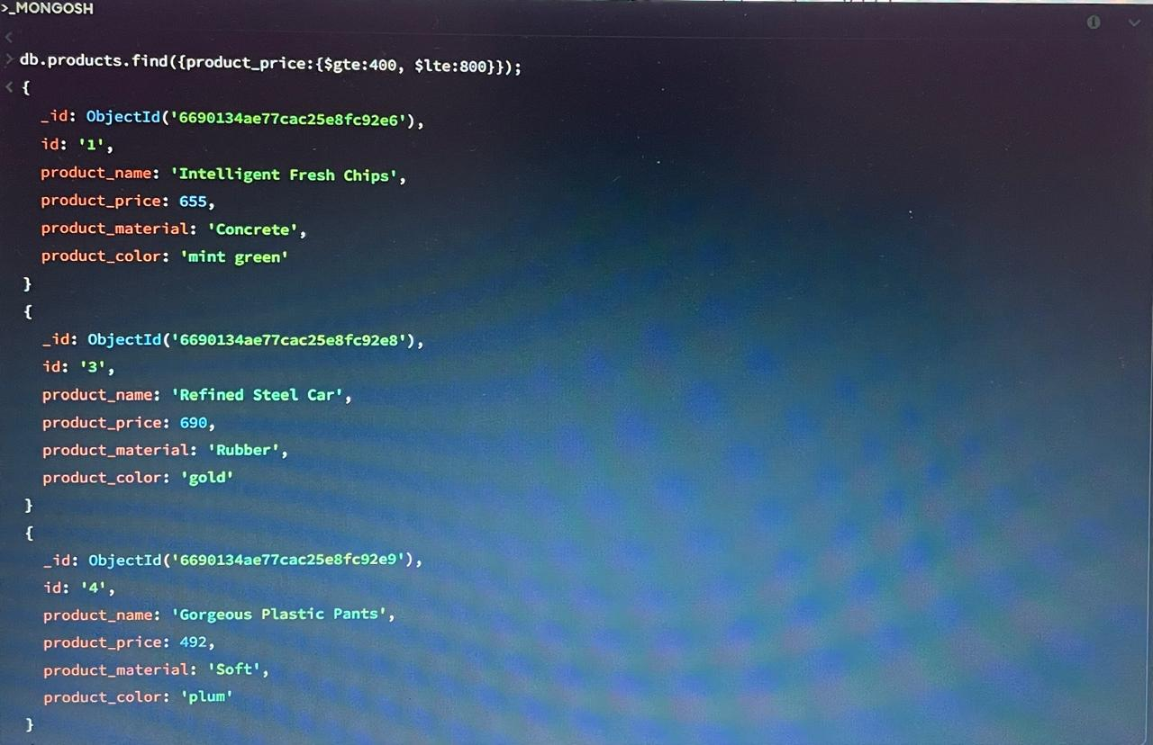

# Q3. Find the product price which are not between 400 to 600

**QUERY:**

**db.products.find({**

**product_price: { $not: { $gte: 400, $lte: 600 }}**

**});**

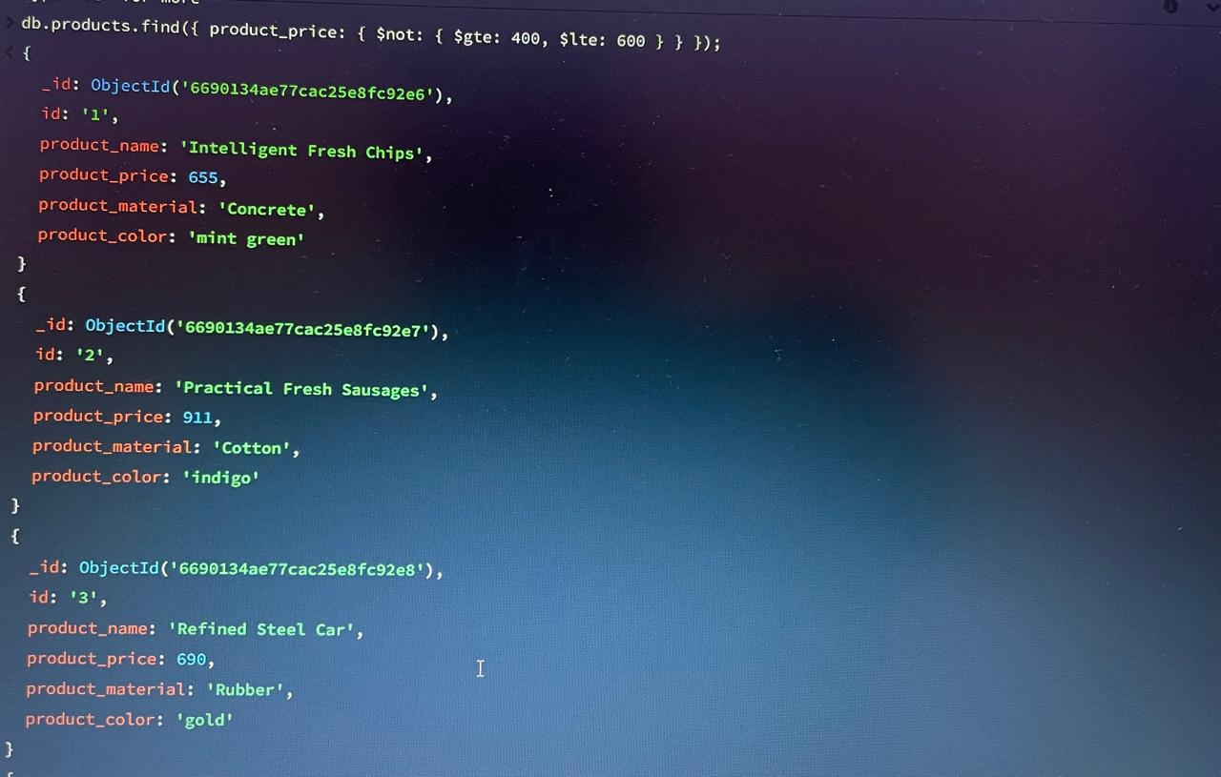

**Q4.** **List the four product which are greater than 500 in price**

**QUERY:** **db.products.find({ product_price: { $gt: 500 }}).limit(4);**

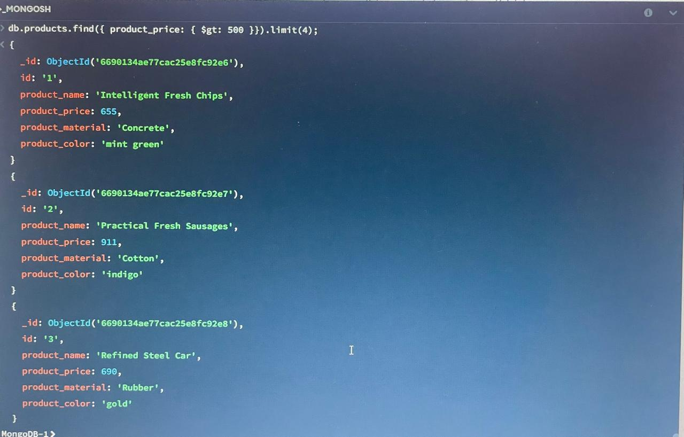

**Q5.** **Find the product name and product material of each product**

**QUERY:**

**db.products.find({},**

**{ _id:0,product_price:1,product_material:1}**

**);**

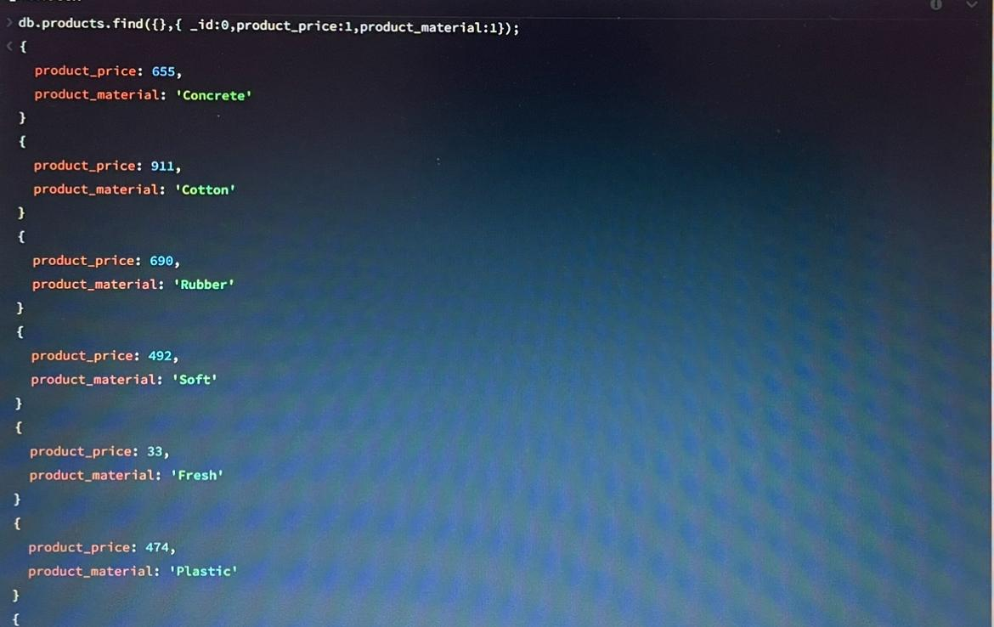

**Q6. Find the product with a row id of 10**

**QUERY:** **db.products.find({ id:'10'});**



**Q7. Find only the product name and product material**

**QUERY:**

**db.products.find({},**

**{ _id:0,product_price:1,product_material:1}**

**);**



**Q8. Find all products which contain the value of soft in product material**

**QUERY:** **db.products.find({product_material:'Soft'});**

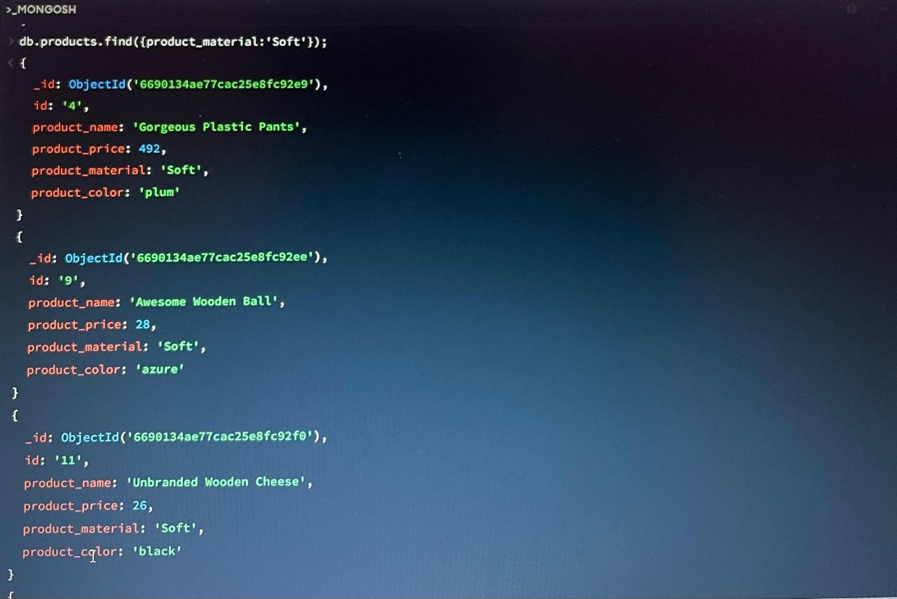

**Q9.** **Find products which contain product color indigo and product price 492.00**

**QUERY:** **db.products.find({**

**$or: [{product_color: 'indigo' },{product_price: 492.00 }]**

**});**

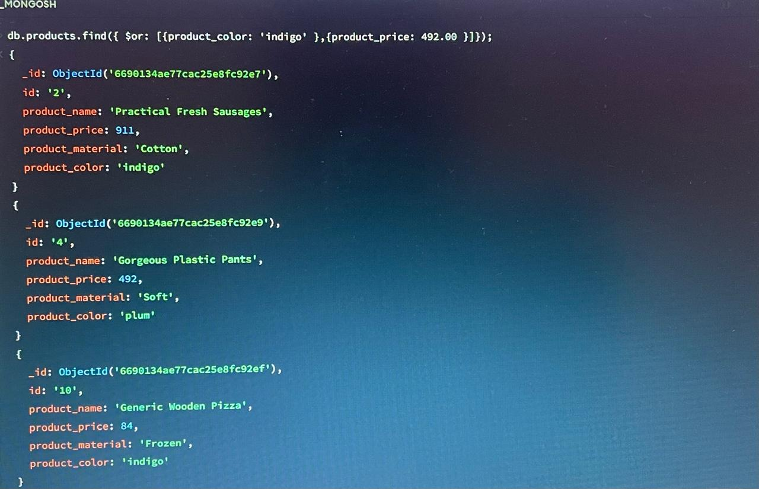

**Q10.** **Delete the products which product price value are 28**

**QUERY: db.products.deleteMany({“product_price”:28.00});**

